Optimal Automatic Generation Control with Hydro, Thermal, Gas, and Wind Power Plants in 2-Area Interconnected Power System

Navapallav Borthakur, Vedansh Pandey under Dr. Avirup Maulik,

Department of Electrical Engineering, Indian Institute of Technology(BHU), Varanasi

#### Abstract—This report explores automatic generation control (AGC) of a more realistic 2-area multi-source power system comprising hydro, thermal, gas, and wind energy sources-based power plants in each control area. The wind power plants (WPPs) have been growing continuously worldwide due to their inherent feature of providing eco-friendly sustainable energy. But, operations of WPPs are associated with system stability problems due to the varying wind speed. To minimize these disturbances and provide for a stable system LQR and LQI controllers have been used and the responses corresponding to them have been verified by the simulation results.

1. **INTRODUCTION**

The present-day power systems are having control areas for supplying electrical energy to the consumer with a sufﬁcient degree of reliability. With the best efforts by power engineers engaged, there is still mismatch between generation and demand due to continuously increasing load demands. The successful operation of a power system requires proper matching of area load demand and scheduled tie-line ﬂows to the area generation. These two balances are predominant factors to identify the healthy operation of the power system and the quality of electricity delivered to the consumers. These balances are achieved by regulating the power generation with load demand. However, if operating frequency of the system is below the rated value, the power production has to be enhanced and if the actual outﬂow is more than the scheduled outﬂow, power production has to be reduced. Besides, conditions of the system are always dynamic due to stochastic nature of the load. Due to this, precise manual control to achieve these balances is inadequate. Therefore, AGC controllers based on modern control concepts are required at control center for regulating the system frequency and tie-line power ﬂows automatically.

The energy sources such that coal, oil, natural gas, diesel, nuclear fuels, and falling water are common for generating electrical power. A wide variety of non-conventional fuels have been identiﬁed for electric power generation technologies due to day by day depletion of fossil fuels. The untiring efforts of engineers/technologists enable the world to use solar energy, wind power and waste materials etc. effectively and efﬁciently for electrical power gener- ation. However, the contribution of non- conventional sources for designing of AGC schemes in interconnected power system is rarely acknowledged. Most of these AGC studies have been done in interconnected power systems by considering single source of power plants in each corresponding control are. However, in practicalsituations, a control area may have combinations of hydro, thermal, gas, and non-conventional energy sources-based power plants. In the literature, AGC studies are car- ried out by considering few energy sources based power plants in corresponding control areas such as hydro-thermal-gas- thermal-hydro-wind- diesel,wind-photovoltaic(PV)-diesel, thermal-wind-

PV-wave, thermal-wind, hydro-thermal- diesel- gas, wind-thermal-split shaft gas turbine, thermal- hydro-wind-PV- geothermal, dish-Stirling solar thermal system (DSTS)-diesel-thermal, wind- thermal-diesel and hydro-biomass-wind- ﬂywheel/micro gas-PV-ﬂy- wheel/micro gas-fuel cell-PV-ﬂywheel/diesel-wind-ﬂy- wheel. Presently, wind power plants (WPPs) are considered as the most popular renewable energy sources for producing electrical energy for consumers.

Optimal AGC controllers are simple to design, offer low cost and robust performance; therefore, in this report LQR and LQI(integral feedback) is adapted for designing and implementation of AGC schemes in power system model under consideration.

Some other applications of optimal AGC controllers in power systems are single/multi-energy source single/multi-area power systems and 2- area restructured single/multi-energy source power systems

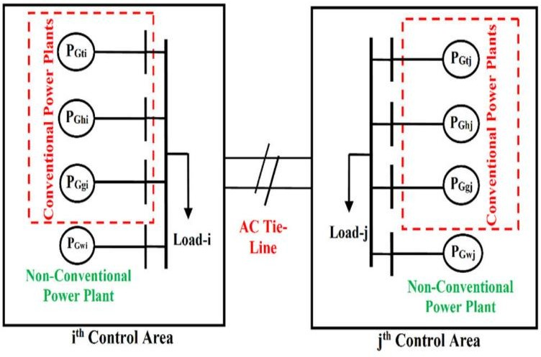

**FIGURE1**. Block diagram model of power systems is having hydro, thermal and gas power plants along with WPPs.

1. **MATHEMATICAL MODEL OF POWER SYSTEM UNDER EXAMINATION**

The generalized model of 2-area interconnected power system in the presence of hydro, thermal and gas power plants along with WPPs in each control area is shown in Figure 1. In this model, *i*th control area is interconnected to *j*th control area via AC tie-line. The power rating of *i*th and *j*th control area is represented by Pri and Prj MW, respectively.

Let Khi, Kti and Kgi along with Kwi be the power shar- ing factors of hydro, thermal and gas power plants along with WPPs, respectively for total power generation in *i*th control area. The value of power sharing factors is evaluated considering the total load demand and scheduled economic load dispatch. The PGhi, PGti and PGgi along with PGwi are power generations in MW by hydro, thermal and gas power plants along with WPPs in the *i*th control area, respectively.

Under normal operating conditions, there is no mis- match between generation and load; then the power generations from hydro, thermal and gas along with WPPs to meet out the total load demand are given by;

PGhi= KhiPGi (1)

PGti=KtiPGi (2)

PGgi=KgiPGi (3)

PGwi=KwiPGi (4)

The total power generated; PGi of *i*th area for nominal generation loading, is mathematically given by:

PGi= PGhi+PGti+PGgi+PGwi (5)

Putting the value of PGhi, PGti, PGgi, and PGwi from Equations

* 1. –(4), then, the value of PGi is given by;

PGi=Khi+Gi+Kti+Gi+Kgi+Gi+Kwi+Gi (6)

Kti+Khi+Kgi+Kwi= 1 (7)

For small load perturbation in *i*th control area, the deviation in power generation; ΔPGi can be formulated usingEq. (5) as;

ΔPGi=ΔPGhi+ΔPGti+ΔPGgi+ΔPGwi (8)

Similarly, for *j*th control area, ΔPGj is given by:

ΔPGj=ΔPGhj+ΔPGtj+ΔPGgj+ΔPGwj (9)

The load frequency characteristic (Di), power system gains constant (KPi), power system time constant (TPi), and bias constant (*bi*) are deﬁned as

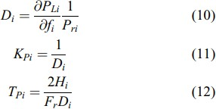

Figure 2.

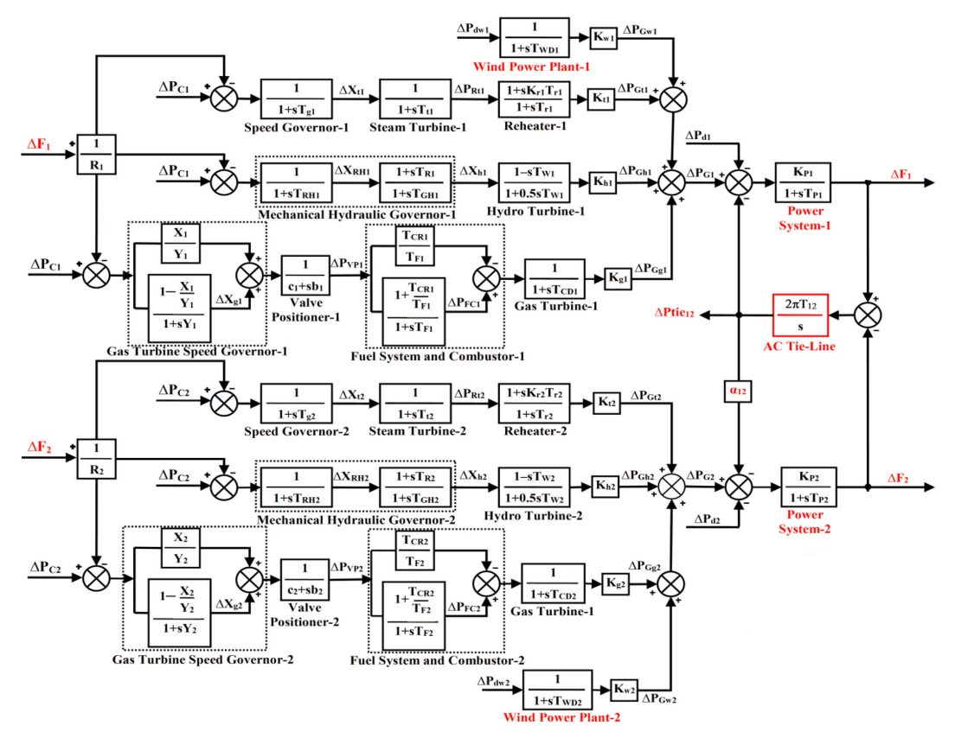

#### >>Data of the system parameters

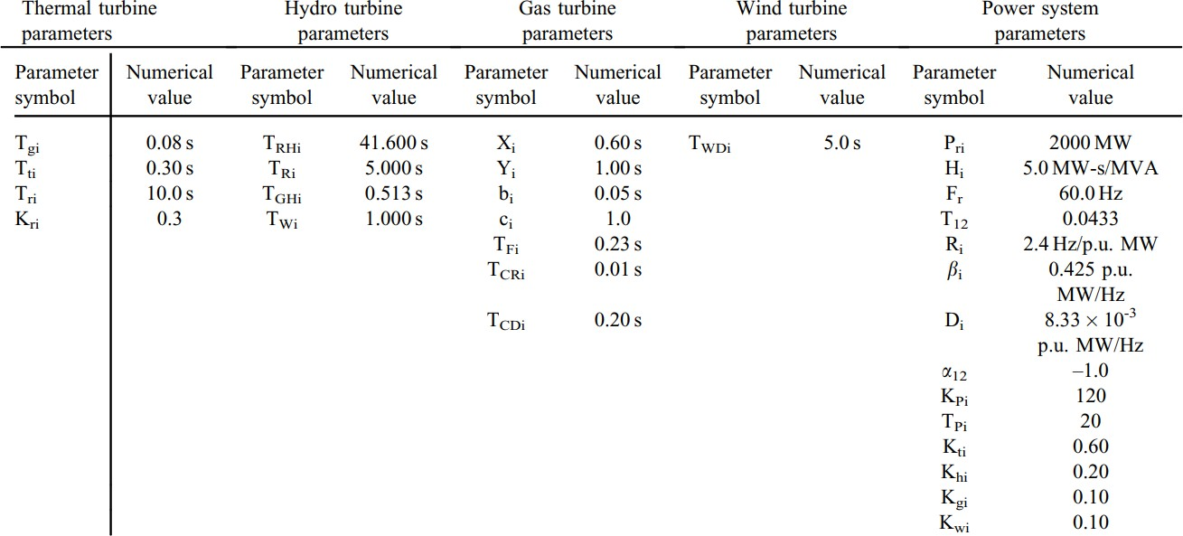

**The SIMULINK Model with values:**

**Area 1:**

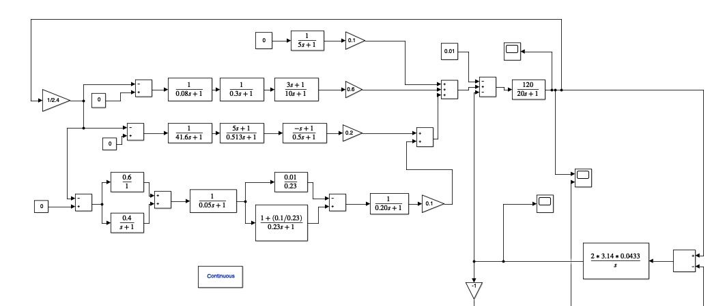

**Area 2:**

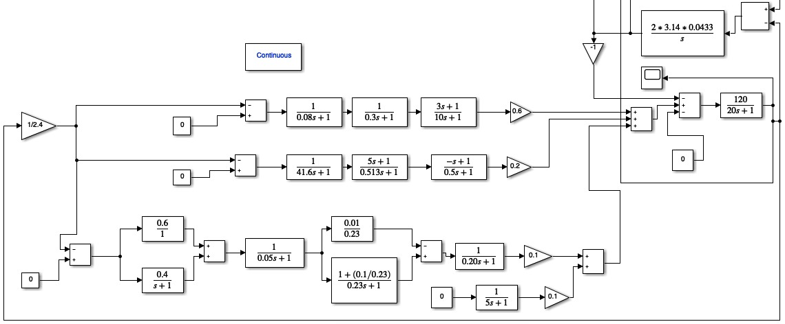





Similarly, the above equations for jth control area can be determined. Using the above equations, the transfer function model of 2-area interconnected power system is developed as shown in Figure 2, with i=1 and j=2. It is a 2-area power system by considering hydro, thermal and gas power plants along with WPPs in each corresponding control area.

#### Dynamic Model of Power System Under Examination

The power system model under examination is a linear continuous time-invariant dynamic system which may be represented by equations;

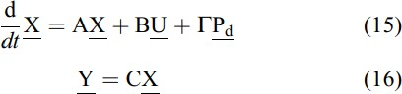

where, X, U, Pd , and Y are state, control, disturbance, and output vectors respectively as well as A, B, U, and C are system, control, disturbance, and output matrices of compatible dimensions, respectively. The structures of these matrices depend on the system parameters and the operating point of the system. The various state vectors and matrices for power system model is derived from the model shown in Figure 2.

#### System Vectors

The state, control, and disturbance vectors for power system model under investigation are given by;

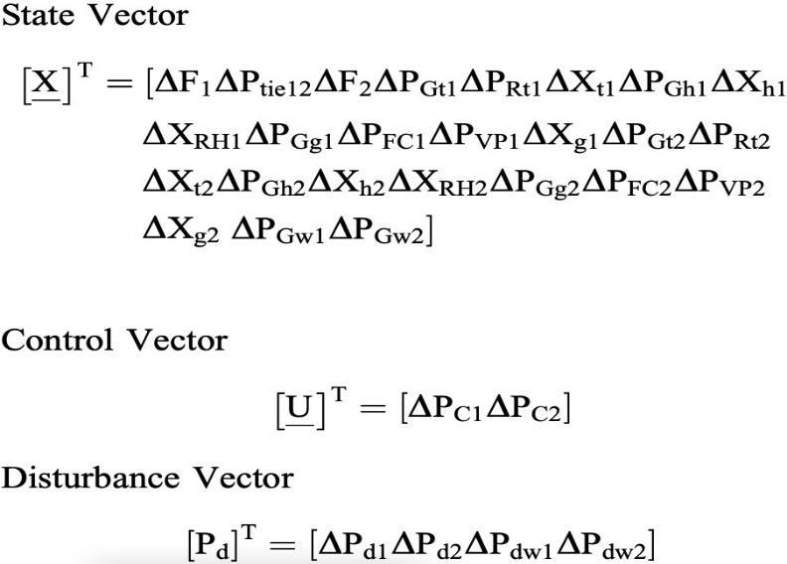

#### System Matrices

From the transfer function model shown in Figure 2, the various differential equations may be derived to develop the state space model of the system, which is given by Eqs. (15) and (16). Total 25 differential equations may be derived for power system model but the same are not given here due to the space limitations. However, the following structure of the system matrices A, B, and U are obtained by arranging these differential equations in the form of Eqs. (15) and (16). The order of state matrix

[A] for power system model taking into investigation is of 25*25. The non-zero elements of this matrix are given as;

A(1,1)=-1/TP1;

A(1,2)=-KP1/TP1; A(1,4)=KP1/TP1; A(1,7)=KP1/TP1; A(1,10)=KP1/TP1;

A(1,24)=KP1/TP1; A(2,1)=2*pi*T12; A(2,3)=-2*pi*T12; A(3,2)=-(al1*KP1)/TP1;

A(3,3)=-1/TP1; A(3,14)=KP1/TP1; A(3,17)=KP1/TP1; A(3,20)=KP1/TP1; A(3,25)=KP1/TP1;

A(4,4)=-1/Tr1;

A(4,5)=(Kt1/Tr1)-(Kr1*Kt1/Tt1); A(4,6)=Kr1*Kt1/Tt1;

A(5,5)=-1/Tt1;

A(5,6)=1/Tt1; A(6,1)=-1/(R1*Tg1);

A(6,6)=-1/Tg1;

A(7,1)=(2*Kh1*TR1)/(TGH1*R1*TRH1); A(7,7)=-2/TW1; A(7,8)=(2*Kh1/TW1)+(2*Kh1/TGH1);

A(7,9)=((2*Kh1*TR1)/(TGH1*TRH1))-(2*Kh1/TGH1);

A(8,1)=-TR1/(TGH1*R1*TRH1); A(8,8)=-1/TGH1;

A(8,9)=(1/TGH1)-(TR1/(TGH1*TRH1)); A(9,1)=-1/(R1*TRH1);

A(9,9)=-1/TRH1;

A(10,10)=-1/TCD1; A(10,11)=Kg1/TCD1;

A(10,12)=-(Kg1*TCR1)/(TF1*TCD1); A(11,11)=-1/TF1; A(11,12)=1/TF1+(TCR1/(TF1*TF1));

A(12,1)=-X1/(b1*R1*Y1);

A(12,12)=-c1/b1; A(12,13)=1/b1;

A(13,1)=(X1/(R1*Y1*Y1))-(1/(R1*Y1)); A(13,13)=-1/Y1;

A(14,14)=-1/Tr1; A(14,15)=(Kt1/Tr1)-(Kr1*Kt1/Tt1); A(14,16)=Kr1*Kt1/Tt1;

A(15,15)=-1/Tt1; A(15,16)=1/Tt1; A(16,3)=-1/(R1*Tg1);

A(16,16)=-1/Tg1;

A(17,3)=(2*Kh1*TR1)/(TGH1*R1*TRH1); A(17,17)=-2/TW1; A(17,18)=(2*Kh1/TW1)+(2*Kh1/TGH1); A(17,19)=((2*Kh1*TR1)/(TGH1*TRH1))- (2*Kh1/TGH1);

A(18,3)=-TR1/(TGH1*R1*TRH1); A(18,18)=-1/TGH1;

A(18,19)=(1/TGH1)-(TR1/(TGH1*TRH1)); A(19,3)=-1/(R1*TRH1);

A(19,19)=-1/TRH1;

A(20,20)=-1/TCD1; A(20,21)=Kg1/TCD1;

A(20,22)=-(Kg1*TCR1)/(TF1*TCD1); A(21,21)=-1/TF1; A(21,22)=1/TF1+(TCR1/(TF1*TF1));

A(22,3)=-X1/(b1*R1*Y1);

A(22,22)=-c1/b1; A(22,23)=1/b1;

A(23,3)=(X1/(R1*Y1*Y1))-(1/(R1*Y1)); A(23,23)=-1/Y1;

A(24,24)=-1/TWD1; A(25,25)=-1/TWD1;

The order of control matrix [B] is 25*2 and its non-zero elements may be given as;

b(6,1)=1/Tg1;

b(7,1)=(-2*Kh1*TR1)/(TGH1*TRH1); b(8,1)=TR1/(TGH1*TRH1); b(9,1)=1/TRH1;

b(12,1)=X1/(b1*Y1); b(13,1)=(1/Y1)-(X1/(Y1*Y1));

b(16,2)=1/Tg1;

b(17,2)=(-2*Kh1*TR1)/(TGH1*TRH1); b(18,2)=TR1/(TGH1*TRH1); b(19,2)=1/TRH1;

b(22,2)=X1/(b1*Y1); b(23,2)=(1/Y1)-(X1/(Y1*Y1));

The order of disturbance matrix [tau] is 25*4; for power system model under investigation and its non-zero elements can be given as;

tau(1,1)=-KP1/TP1; tau(3,2)=-KP1/TP1; tau(24,3)=1/TWD1; tau(25,4)=1/TWD1;

The order of design matrix [Q] is 25*25; Q should be a positive definite matrix. We take it as a diagonal matrix with suitable diagonal elements;

design matrix R is taken to be a diagonal matrix with +ve diagonal elements and output matrices [C] are considered to be identity matrix of appropriate dimension.

#### VALUES OF THE VARIABLES USED:

Tg1=0.08; Tt1=0.30; Tr1=10.0; Kr1=0.3; TRH1=41.600; TR1=5.000; TGH1=0.513; TW1=1.000; X1=0.60; Y1=1.00; b1=0.05; c1=1.0; TF1=0.23; TCR1=0.01; TCD1=0.20;

TWD1=5.0; T12=0.0433; R1=2.4; bt1=0.425; al1=-1.0; KP1=120; TP1=20; Kt1=0.60; Kh1=0.20; Kg1=0.10; KW1=0.10;

#### SIMULATION RESULTS

The model of power system shown in Figure 2 is simulated on MATLAB platform. The power system data used for the study are given above. The optimal gains of non-optimal AGC controller only with two measurable states, optimal feedback gain matrix [W*] of full state vector feedback optimal AGC controller and the patterns of closed-loop eigenvalues obtained for power system model under investigation.

#### RESULT DISCUSSION

The **eigen-values** so obtained are-:

-19.9837 + 0.0000i

-19.9838 + 0.0000i

-12.6556 + 0.0000i

-12.6587 + 0.0000i

-5.5266 + 0.0000i

-5.4955 + 0.0000i

-3.9487 + 0.0000i

-0.1659 + 2.0497i

-0.1659 - 2.0497i

-3.9213 + 0.0000i

-1.5463 + 0.0000i

-2.6244 + 0.4760i

-2.6244 - 0.4760i

-2.6369 + 0.2758i

-2.6369 - 0.2758i

-0.6812 + 0.6928i

-0.6812 - 0.6928i

-1.2899 + 0.0000i

-0.9485 + 0.0000i

-0.2842 + 0.0000i

-0.0967 + 0.0000i

-0.0289 + 0.0000i

-0.0240 + 0.0000i

-0.2000 + 0.0000i

-0.2000 + 0.0000i

The MATLAB simulations for frequency outputs are shown as in the figures below:

**∆F1:**

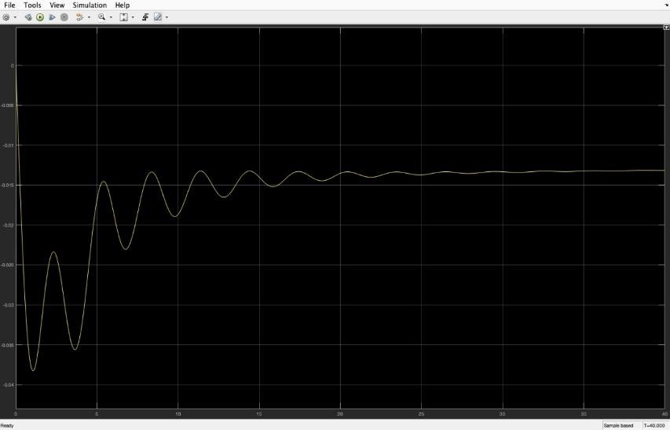

**∆F2:**

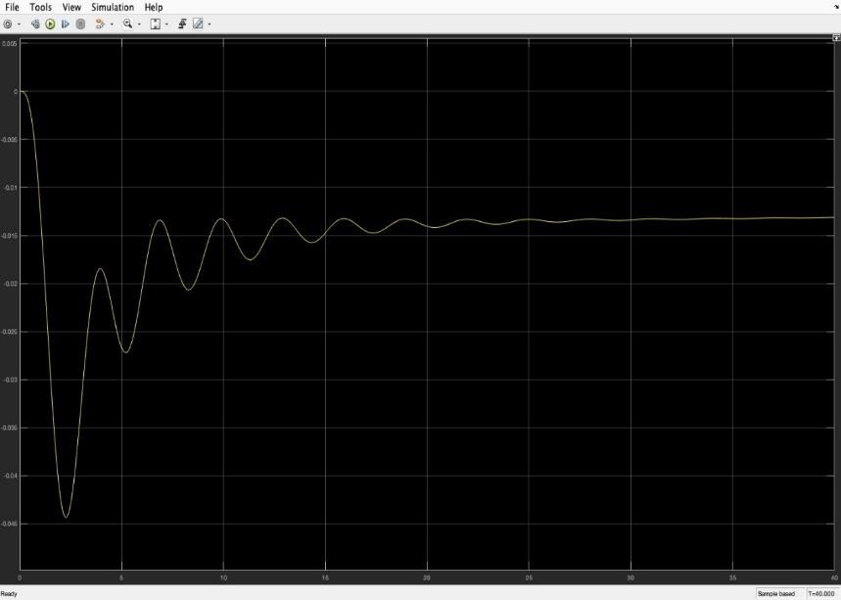

**5.DESIGNING THE CONTROLLER :**

1. WITHOUT APPLYING ANY “OPTIMAL” CONTROLLER METHOD ⇒

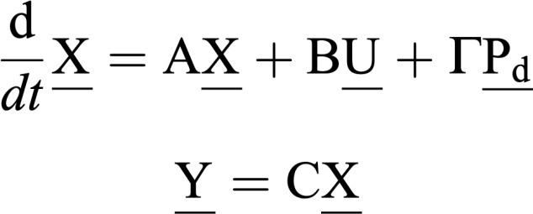We try plotting the graphs for ∆F1 (stateX1) and ∆F2 (state X3) without using any controller mechanism for the following system

(Here,for a feedback control system the matrix ‘D’ is assumed zero) In our MATLAB codes, the following is our naming convention=>

a=>matrix A b=>matrix B u=> matrix U tau=>matrix T

delp=> matrixPd c=> matrix C bt1=>βi

al1=>a12

ad=> discretized matrix A

bd=> discretized matrix B cd=>discretized matrix C (here, same as C)

taud=>discretized matrix T

delt=>time interval for each iteration

xa=>initial matrix X

x=>stores matrix dX/dt in each iteration time(it)=> time matrix for each iteration y(it)=> Y matrix for each iteration

gain=> matrix K in [K,S,e] = LQR(A,B,Q,R,N)

We have applied only one disturbance (i.e.∆Pd1) for all the 3 controller types.

# For Output ∆F1 (state X1)=>

# delt=10^-3

**% discretization of**

**% matrices [ad,bd]=c2d(a,b,delt); [ad1,taud]=c2d(a,tau,delt); xa=zeros(25,1);**

**u=[0**

**0];**

**delp=[0.01 0**

**0**

**0];**

**c=zeros(1,25);**

**% for ∆F1(x1)**

**c(1,1)=1;**

**t=0;**

**it=1; y(1)=0;**

**time(it)=t; cd=c; while t<30**

**it=it+1; x=ad*xa+bd*u+taud*delp; y(it)=cd*x;**

**xa=x; t=t+delt;time(it)=t;**

**end plot(time,y);**

# For Output ∆F2 (state X3)=>

**delt=10^-3;**

**% discretization of**

**% matrices [ad,bd]=c2d(a,b,delt); [ad1,taud]=c2d(a,tau,delt); xa=zeros(25,1);**

**u=[0**

**0];**

**delp=[0.01 0**

**0**

**0];**

**c=zeros(1,25);**

**% for ∆F2(x3)**

**c(1,3)=1;**

**t=0;**

**it=1; y(1)=0;**

**time(it)=t; cd=c; while t<30**

**it=it+1; x=ad*xa+bd*u+taud*delp; y(it)=cd*x;**

**xa=x; t=t+delt; time(it)=t;**

**end plot(time,y);**

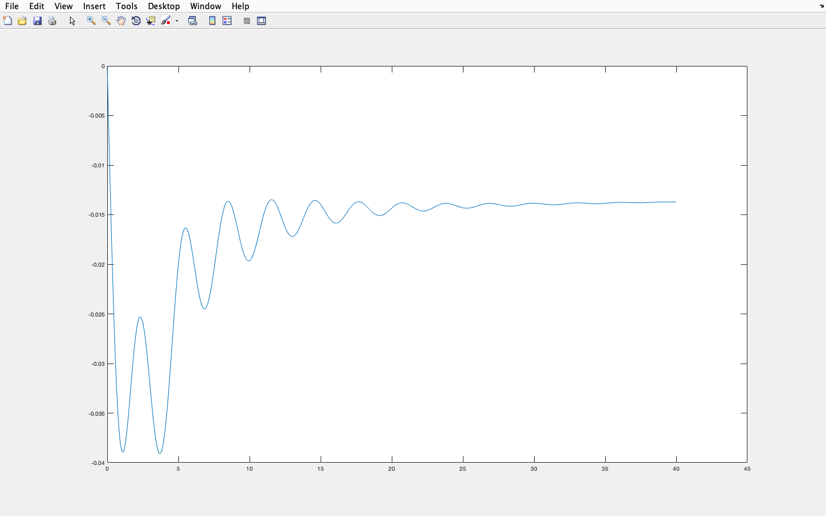 **Graph for ∆F1 (state X1)=>**

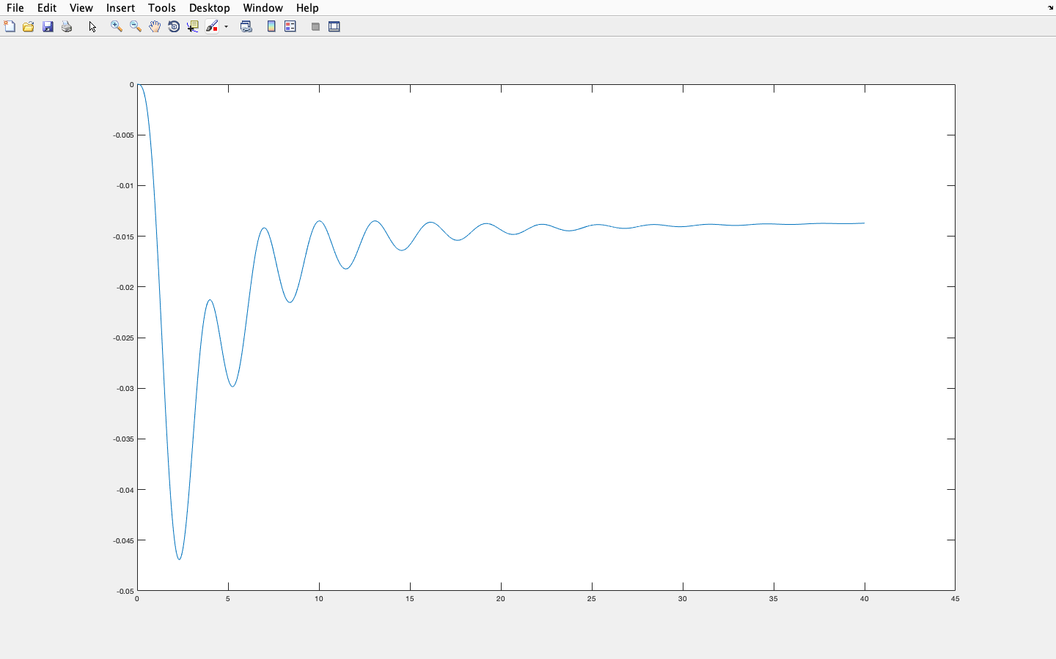**Graph for ∆F2 (state X3)=>**

We can see that the graphs obtained here are similar to the MATLAB-SIMULINK model. It has a lot of steady state error and also the steady state is reached very late.

1. DESIGNING AN LQR (LINEAR QUADRATIC REGULATOR) CONTROLLER=> Objective of LQR:

Design of optimal controllers for linear systems with quadratic performance index known as Linear Quadratic Regulator (LQR) for load frequency control system are realized below. The objective of optimal regulator design is to determine the optimal control law which can transfer the system from its initial state to the final state such that given performance index (PI) is minimized

We use LQR to determine the optimal control law u*(x,t) which can transfer the system from its initial state to the final state such that a given performance index is minimized.

The PI is selected to give the best trade-off between performance and cost of control. The PI is widely used in optimal control design is known as quadratic performance index and is based on minimum error and minimum energy criteria.

Syntax:

**[K,S,e] = lqr(SYS,Q,R,N)**

**[K,S,e] = LQR(A,B,Q,R,N)**

**Description:**

**[K,S,e] = lqr(SYS,Q,R,N) calculates the optimal gain matrix K.**

**([Q] and [R] are weighting matrices for the system state and the input variables)**

**For a continuous time system, the state-feedback law *u* = –*Kx* minimizes the quadratic cost function**



**subject to the system dynamics**



**In addition to the state-feedback gain K, lqr returns the solution S of the associated Riccati equation**



**and the closed-loop eigenvalues e = eig(A-B*K). *K* is derived from *S* using**



**For a discrete-time state-space model, *u*[*n*] = –*Kx*[*n*] minimizes**

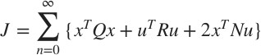

**subject to *x*[*n* + 1] = *Ax*[*n*] + *Bu*[*n*].**

**[K,S,e] = LQR(A,B,Q,R,N) is an equivalent syntax for continuous-time models with dynamics**



**In all cases, when we omit the matrix N, N is set to 0. Our Desgin=>**

**The matrices a,b,u,tau,delp,c,ad,bd,cd,taud,xa,x,y(it),gain and delt all have same meaning as that used in the without any “ Optimal ” controller part.( so their definition is omitted again )**

|  |  |  |
| --- | --- | --- |
| **For Output ∆F1 (state** | **X1)=>** |  |
| **% defining the Q,R,N Matrices Q=100*eye(25);** |  | **For Output ∆F2 ( state X3)=>** |
| **v2=[50 50];**  **R=diag(v2); N=zeros(25,2); c=zeros(1,25);**  **% for ∆F1(x1)**  **c(1,1)=1;**  **t=0;**  **it=1; y(1)=0;**  **time(it)=t; cd=c;**  **% applying lqr [gain,sy,er]=lqr(a,b,Q,R,N); while t<40**  **it=it+1; x=ad*xa+bd*u+taud*delp; y(it)=cd*x;**  **xa=x; t=t+delt; time(it)=t; u=-gain*xa;**  **end**  **plot(time,y);** |  | **% defining the Q,R,N Matrices Q=100*eye(25);**  **v2=[50 50];**  **R=diag(v2); N=zeros(25,2); c=zeros(1,25);**  **% for ∆F2(x3)**  **c(1,3)=1;**  **t=0;**  **it=1; y(1)=0;**  **time(it)=t; cd=c;**  **% applying lqr [gain,sy,er]=lqr(a,b,Q,R,N); while t<40**  **it=it+1; x=ad*xa+bd*u+taud*delp; y(it)=cd*x;**  **xa=x; t=t+delt; time(it)=t;**  **u=-gain*xa;** |

**end plot(time,y);**

**Graph for ∆F1 (state X1)=>**

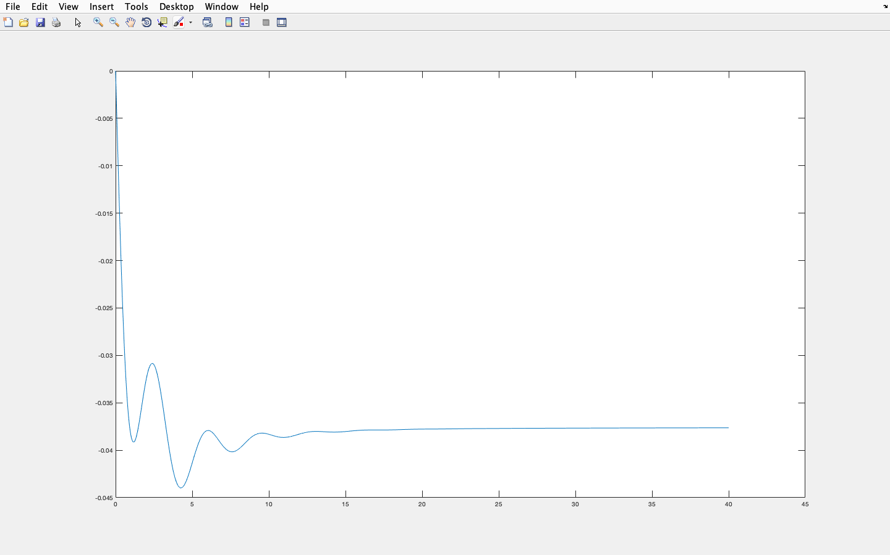

**Graph for ∆F2 (state X3)=>**

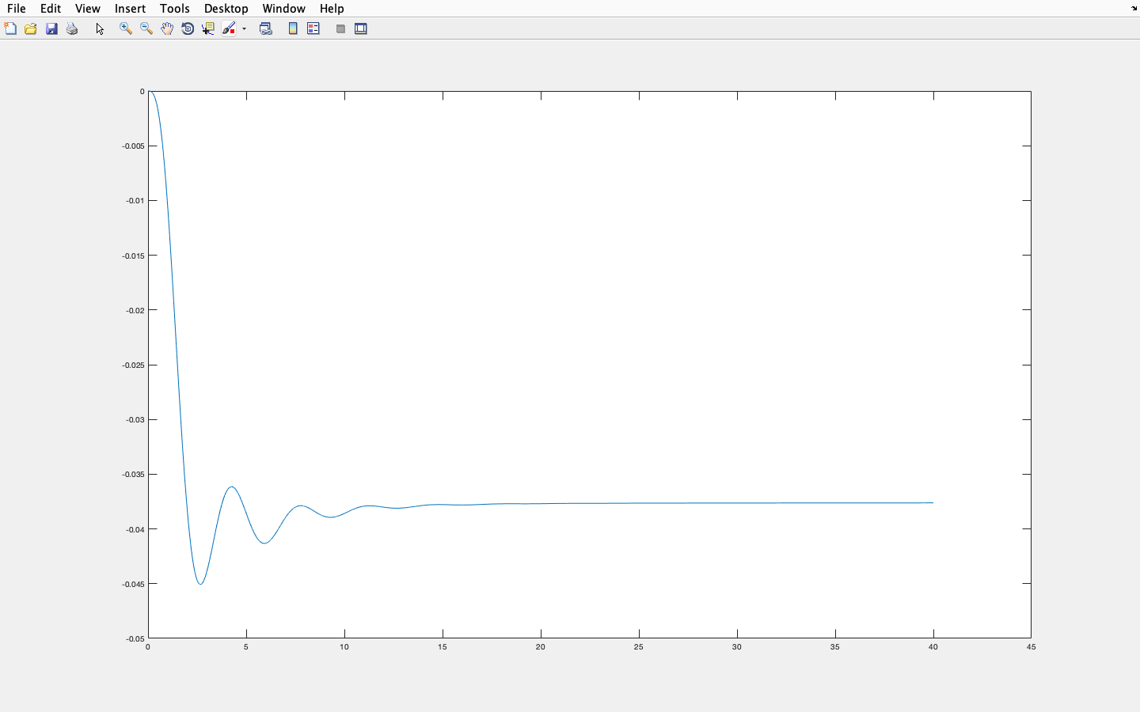

In the above graphs, we can see that the steady state is reached earlier, but there are still steady state errors. To reduce these disturbances we design a more accurate controller known as the LQI controller.

1. DESIGNING AN LQI (LINEAR QUADRATIC INTEGRATOR) CONTROLLER=>

Objective of LQI:

LQI (linear quadratic integrator) uses integral feedback to eliminate steady state error.The controller based on state feedback achieves the correct steady state response to reference signals by careful computation of the reference input u. This requires a perfect model of the process in order to insure that (x, u) satisfies the dynamics of the process. However, one of the primary uses of feedback is to allow good performance in the presence of uncertainty, and hence requiring that we have an exact model of the process is undesirable. An alternative to calibration is to make use of integral feedback, in which the controller uses an integrator to reduce steady state error

Instead, of directly using LQI, we have augmented the state space equation derived matrices with an integral action and implemented the LQR controller

INCORPORATING AN INTEGRAL ACTION IN LQR BY AUGMENTING SYSTEM MATRIX WITH ERROR IN THE STATE VARIABLE:

The LQR control law essentially gives a multivariable proportional regulator. An integral action has been incorporated in the LQR controller in order to eliminate the offset. An integral action has been incorporated in the LQR controller by augmenting the system with error in the state variable. One new state is added to the space model of the system.

Our Original system=>

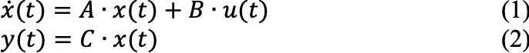

We define integral state q as follows: q̇ **= -y = - Cx**

**Therefore the system (1) and (2) after augmenting with integral state, q becomes,**

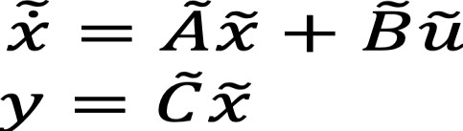

**Where,**

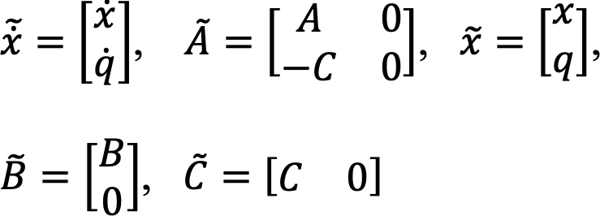

**Our Desgin=>**

The matrices a,b,u,tau,delp,c,taud,xa,x,y(it),gain and delt all have same meaning as that used in the without any “ Optimal ” controller part.( so their definition is omitted again ).The order of Q is increased to 26x26.The order of R remain same.The order of N is increased to 26x2

The other convention add-ons are :

### ak=>augmented matrix A̅ bk=>augmented matrix B̅ ck=>augmented matrix C̅ q=>integral state xak=>augmented matrix X̅a tauk=>augmented matrix T

**ad, bd, taud=> discretized matrices A, B,T cd=>discretized matrix C̅ (here, same as C̅ )**

**For this method, only one Riccati equation is to be solved to get the optimal control law.**



**Where, S is the solution of above Riccati equation. Here, these A̅ and B̅ are augmented matrices with error in state variable.**

**The optimal control law is=>**

**For both ∆F1 and ∆F2=>**

**% defining the Q,R,N Matrices Q=100*eye(25);**

**Q(26,:)=0;**

**Q(:,26)=0;**

**Q(26,26)=100; v2=[50 50];**

**R=diag(v2);**

**N=zeros(26,2);**

## For Output ∆F1 ( state X1)=>

**c=zeros(1,25);**

**% for ∆F1(x1) c(1,1)=1;**

**t=0;**

**it=1; y(1)=0;**

**time(it)=t;**

**% getting the value of q fun=@(y) -y; q=integral(fun,0,1); xak=[xa;q];**

**% augmenting the matrices ck=[c 0];**

**cd=ck; bk=[b;0 0];**

**tauk=[tau;0 0 0 0]; ve1=zeros(25,1); a=[a ve1];**

**c=[c 0];**

**ak=[a;-c];**

**% applying lqr**

**% after augmenting [gain,sy,er]=lqr(ak,bk,Q,R,N);**

**[ad,bd]=c2d(ak,bk,delt); [ad1,taud]=c2d(ak,tauk,delt); while t<40**

**it=it+1;**

**x=ad*xak+bd*u+taud*delp; y(it)=cd*x;**

**xak=x; t=t+delt; time(it)=t; u=-gain*xak;**

**end plot(time,y);**

## For Output ∆F2 ( state X1)=>

**c=zeros(1,25);**

**% for ∆F2(x3)**

**c(1,3)=1; t=0;**

**it=1; y(1)=0;**

**time(it)=t;**

**% getting the value of q fun=@(y) -y; q=integral(fun,0,1); xak=[xa;q];**

**% augmenting the matrices ck=[c 0];**

**cd=ck; bk=[b;0 0];**

**tauk=[tau;0 0 0 0]; ve1=zeros(25,1); a=[a ve1];**

**c=[c 0];**

**ak=[a;-c];**

**% applying lqr**

**% after augmenting [gain,sy,er]=lqr(ak,bk,Q,R,N);**

**[ad,bd]=c2d(ak,bk,delt);**

**[ad1,taud]=c2d(ak,tauk,delt); while t<40**

**it=it+1; x=ad*xak+bd*u+taud*delp; y(it)=cd*x;**

**xak=x;**

**t=t+delt; time(it)=t; u=-gain*xak;**

**end plot(time,y);**

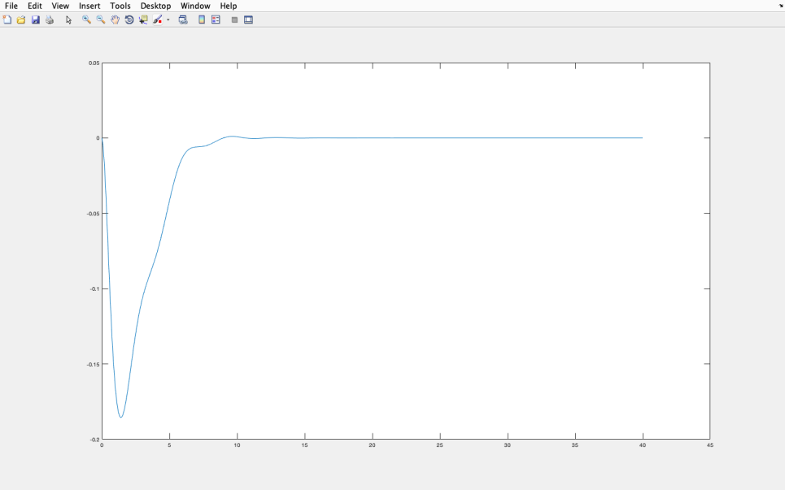**Graph for ∆F1 (state X1)=>**

**Graph for ∆F2 (state X3)=>**

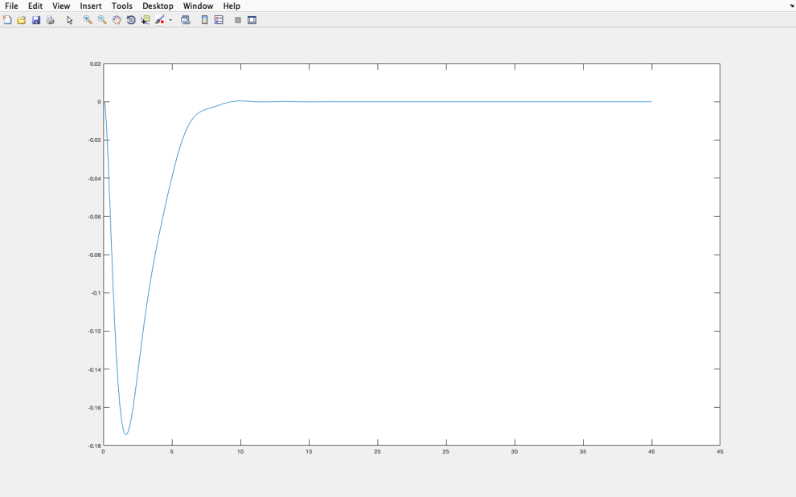

**We see that the steady state is reached much earlier and the steady state errors are reduced.**

**REFERENCES=>**

1. Nizamuddin Hakimuddin, Ibraheem Nasiruddin, Terlochan Singh Bhatti & Yogendra Arya (2020) :Optimal Automatic Generation Control with Hydro, Thermal, Gas, and Wind Power Plants in 2- Area Interconnected Power System - Electric Power Components and Systems, Vol. 0 (2020), No. 0; 1-6,10-11,13-14

2. I.J. Nagrath, M. Gopal (4th ed:2006): Control Systems Engineering - New Age International Publishers

3. Hanmant G. Malkapure, M. Chidambaram (2014):Comparison of Two Methods of Incorporating an Integral Action in Linear Quadratic Regulator - Third International Conference on Advances in Control and Optimization of Dynamical Systems, Kanpur, India; 56,60

4. R. M. Murray (2006):Lecture 2 – LQR Control ( CDS 110b ) - California institute of technology ( Control and Dynamical Systems );1-5

5. Nilaykumar N. Shah, Anamika R. Pandit, Mansi T. Shah, Sherin Cherin, Sheetal G. Vsava(2016):

automatic load frequency control of two area system using l-q-r method - international journal of current engineering and scientific research (IJCESR), volume-3, issue-6;54-60

6. in.mathworks.com/help/control/ref/lqr.html

7. in.mathworks.com/help/control/ref/ss.lqi.html